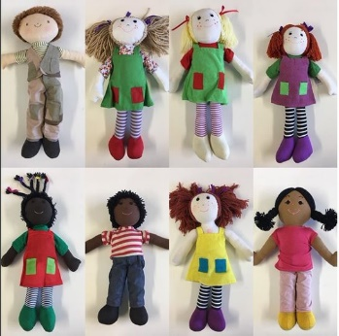
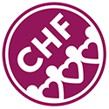
Sponsor a Molly’s Dolly
By donating £2 a month you will fund the annual provision of a specially made surgically-scarred rag doll to a child with a heart condition. Molly’s Dollies are used to introduce the idea of operations and scars to these children, the children also take the dolls (whose scars match their own) along with them to hospital visits and appointments.

I wish to Sponsor a Molly’s dolly by donating £2 per month to the Children’s Heart Federation.
Gift Aid Declaration – Boost your donation by 25p of Gift Aid for every £1 you donate.
Gift Aid is reclaimed by the charity from the tax you pay for the current tax year. Your address is needed to identify you as a current UK taxpayer.
In order to Gift Aid, you must tick the box.
I want to Gift Aid my donation and any donations I make in the future or in the past 4 years I make to The Children’s Heart Federation. I am a UK taxpayer and understand that if I pay less Income Tax and/or Capital Gains Tax than the amount of Gift Aid claimed on all my donations in that tax year it is my responsibility to pay any difference.
Please notify the charity if you: want to change your name, home address, or no longer pay sufficient tax on your income and/or capital gains.

Full Name……………………………………….Signature…………………………………………...
Address………………………………………………………………………………………………….
Town…………………………………………… Postcode……………………………………………
Telephone……………………………………... Email..………………………………………………
Card Details
Card Number……………………………………………………………………………………………
Expiry Date…………………………………… CVC…………………………………………………

We thank you for your support and will keep you informed of news by our e-newsletter. Please tick this box if you do not wish us to use your email address for this purpose.
The personal data provided on this form will be used for marketing, fundraising and administrative purposes only, and will not be transferred to third parties without your explicit consent.

